
Viewed by:
Philippe POHER
Tel.: +33 (0)2 99 27 92 92
E-mail: philippe.poher@iwedia.com

Written by:
Olivier Gaste
Tel.: +33 (0)2 99 27 92 92
E-mail: olivier.gaste@iwedia.com
IWEDIA

TDAL_AVS Technical Specifications

V2.0

Approved by:
Thierry GARNIER
Tel.: +33 (0)2 99 27 92 92
E-mail: thierry.garnier@iwedia.com

SUMMARY
1 Reference documents 3
2 Documentation History 4
3 Introduction 5
4 Module Overview and Architecture 6
4.1 Definitions, Acronyms and Abbreviations 6
4.2 General Description 6
4.2.1 SCART 6
4.2.1.1 General description 6
4.2.1.2 Loopthrough 7
4.2.1.3 Slowblanking 8
4.2.1.4 FastBlanking 8
4.2.2 RCA 9
4.2.3 Others Outputs 9
4.3 Architecture 10
4.4 TDAL_AVS API Description 11
4.4.1 Generic Interface 11
5 TDAL_AVS API Specification 12
5.1 Type Specifications 12
5.1.1 Initialisation 12
5.1.2 General 12
5.2 TDAL_AVS API Usage 13
5.2.1 Set Audio on Scart TV 13
5.2.2 Set Video on Scart TV 13
5.2.3 Set a loopthough (ScartTV from ScartVCR) 15
5.3 TDAL_AVS Macro/Define/Enum/Typedef/Structure Definitions 16
5.3.1 Define Definitions 16
5.3.1.1 kTDAL_AVS_MAX_VALUE_TV_AUDIO_LEVEL 16
5.3.2 Enum Definitions 17
5.3.2.1 tTDAL_AVS_Error 17
5.3.2.2 tTDAL_AVS_Object 17
5.3.2.3 tTDAL_ AVS_OutputDevice 17
5.3.2.4 tTDAL_ AVS_InputDevice 17
5.3.2.5 tTDAL_AVS_SignalType 18
5.3.2.6 tTDAL_AVS_MuteState 18
5.3.2.7 tTDAL_AVS_FastBlankingLevel 18
5.3.2.8 tTDAL_AVS_SlowBlankingLevel 19
5.3.3 Structure Definitions 20
5.3.3.1 tTDAL_AVS_Level 20
5.4 TDAL_AVS API Functions 21
5.4.1 Generic Interface API 21
5.4.1.1 TDAL_AVS_Init(-) 21
5.4.1.2 TDAL_AVS_Term(-) 22
5.4.1.3 TDAL_AVS_SelectInput(-) 23
5.4.1.4 TDAL_AVS_APIRevisionGet(-) 24
5.4.1.5 TDAL_AVS_PlatformRevisionGet(-) 25
5.4.1.6 TDAL_AVS_SelectSignalType(-) 26
5.4.1.7 TDAL_AVS_SelectLevel(-) 27
5.4.1.8 TDAL_AVS_Mute(-) 28
5.4.1.9 TDAL_AVS_SelectSlowBlanking(-) 29
5.4.1.10 TDAL_AVS_SelectFastBlanking(-) 30
5.4.1.11 TDAL_AVS_EnableAutomaticLoopthrough(-) 31

Reference documents
The following documents were used to write this specification:

Document | Version | Title

Documentation History

History
Vers. | Date | Nature
1.0 | 27/06/2002 | GAO : creation
1.1 | 26/04/2004 | AGO : update
1.2 | 26/04/2004 | Editorial review
1.3 | 24/11/2004 | AGO : modification for automatic loop through management
1.4 | 07/12/2004 | ARV : added some remarks at the end.
1.5 | 17/02/2005 | ARV : added :  - a eTDAL_AVS_NOT_INIT error code  - a TDAL_AVS_Term function
2.0 | 11/01/2007 | DUF : Editorial review

Introduction
The purpose of this document is to specify the interface and to describe the internal design of the Thin Driver Adaptation Layer Audio Video Switch [TDAL_AVS]. The aim of this module is to provide a complete interface between middlewares and the control of the Audio/Video switch Chip of a set-top-box. (e.g. STV6414, STV6417 or AK4702). It makes the audio and video routings required in a SCART between a set top box and the Audio/Video equipments (including TVs, VCRs, DVD players).

Module Overview and Architecture

Definitions, Acronyms and Abbreviations
CVBS | Composite Video Blanking and Sync (also Composite)
YC | Another name for S-Video
S-Video | Separate video with two signals (brightness and colour)
YUV | Luminance and colour difference signal in component video system
RGB | Red-Green-Blue
SD | Standard Definition
HD | High Definition
RCA | Radio Corporation of America
SCART | Syndicat Français des Constructeurs d'Appareils Radio et Télévision connector
SPDIF | Sony/Philips Digital Interface Format

General Description
The main job of the TDAL_AVS is to control audio and video output stage on a scart on a set-top-box (Analog Signals). The module manages only the signals coming from the encoder and not the signals coming from the scart input(TV).
With some hardwares, the module TDAL_AVS controls also the RCA connector.
Some general descriptions need first to be done.

SCART

General description
A scart is a associated 21-pin connector for connecting audio-video equipment together. It gathers together various common analog signal types into a single connector. The signal carried by Scart include :
- for the video: the Composite(CVBS) , the S-Video(YC) and the RGB input/output. (but SCART cannot carry both S-Video and RGB signals at the same time.)
- for the audio: the stereo(AL,AR) input/output.
In addition, a TV can be awakened from standby mode or switched to video mode through a Scart.
The following diagram shows a female connector:
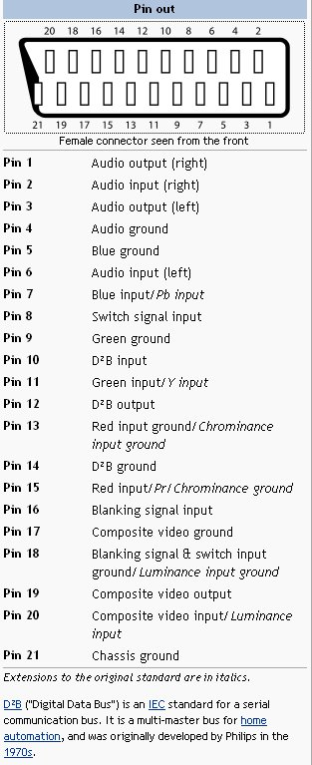

Loopthrough
A Scart is bi-directional regarding standard composite video (RGB connections are not bidirectional) and anolog audio. A set-top-box set will typically send the antenna audio and video signals to the scart all the time and watch for returned signals, to display and reproduce them instead.
This allows "transparent" set-top boxes, without any tuner, which just "hook" and pre-process the television signals. This feature is used for analog Pay TV like Canal Plus.
Some set-top-boxes have two scarts; the scart connected to the TV is called the scart TV and the other scart is the scart VCR.
This specificity allows the loopthough: the signal from a scart is re-directed on the other scart. It is used for the record with a VCR or a DVD player.
When the loopthough is activated, the equipement which is on the scart VCR becomes the master when it is power on. The screen of the TV displays the signal coming from the scart VCR, in which case it would be inadvisable to change channels on the television set during the recording.

Slowblanking
SCART supports automatic widescreen switching. The widescreen pin enables to inform the current signal format, which allows widescreen sets to adjust the image width.
Pin 8, the switch signal pin, carries a low frequency (less than 50 Hz) signal from the source that indicates the type of video present.
0 V–2 V means no signal, or internal bypass
4.5 V–7 V (nominal 6 V) means a widescreen (16:9) signal
9.5 V–12 V (nominal 12 V) means a normal (4:3) signal

FastBlanking
Pin 16, the blanking signal pin, carries a signal from the source that indicates that the signal is either RGB or composite.
0 V–0.4 V means composite.
1 V–3 V (nominal 1 V) means RGB only.

RCA
A RCA is two-wire(signal and ground) coaxial cable that is widely used to connect analog audio and video components.
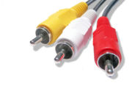
In some Set Top Boxes (but it becomes rarely), the RCA is controled by the module TDAL_AVS. It just enables or disables the ouput audio and video.

Others Outputs
The outputs like the SPDIF or the HDMI are managed by others modules.
The TDAL_AV for the SPDIF and the TDAL_HDMI for the HDMI.

Architecture
The figure below shows the relation between the client module and the low level drivers:
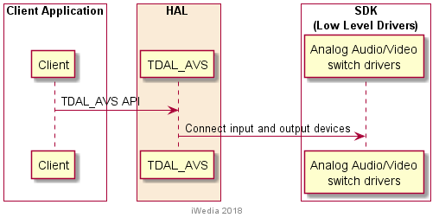

TDAL_AVS API Description

Generic Interface
The generic interface allows clients to control the TDAL_AVS module.
This interface is used with the following functions:
- TDAL_AVS_Init(-) in order to initialize the TDAL_AVS module.
- TDAL_AVS_Term(-) in order to terminate the TDAL_AVS module.
- TDAL_AVS_APIRevisonGet(-) in order to retrieves the API revision
- TDAL_AVS_PlatformRevisonGet(-) in order to retrieves the platform implementation revision.
- TDAL_AVS_SelectInput(-) in order to select an input for a particular output device.
- TDAL_AVS_SelectSignalType(-) in order to select a signal type for a particular output device.
- TDAL_AVS_SelectLevel(-) in order to select a level for a particular output device.
- TDAL_AVS_Mute(-) in order to mute or unmute a particular output device.
- TDAL_AVS_SelectSlowBlanking(-) in order to select the level of Slow Blanking for a particular output device.
- TDAL_AVS_SelectFastBlanking(-) in order to select the level of Fast Blanking for a particular output device.
- TDAL_AVS_EnableAutomaticLoopthrough(-) in order to activate or stop the loopthough(TV from VCR).

TDAL_AVS API Specification

Type Specifications

Initialisation
After the call to the function TDAL_AVS_Init, the driver must be initialised with defaults parameters.

General
tTDAL_AVS_Object is used to define the type of the signal to used (Video/audio).
tTDAL_ AVS_OutputDevice is used to defined the signal output scart (TV, VCR…)
tTDAL_ AVS_InputDevice is used to defined the input signal input scart (VCR, ENCODER…)
tTDAL_AVS_FastBlankingLevel is used to defined the type of the video signal(RGB, CVBS…)
tTDAL_AVS_SlowBlankingLevel is used to defined the type of the output screen(16_9/4_3…)

TDAL_AVS API Usage

Set Audio on Scart TV
The initialisation of TDAL_AVS API is made. The signal source, the signal type and the level are set by the others functions.

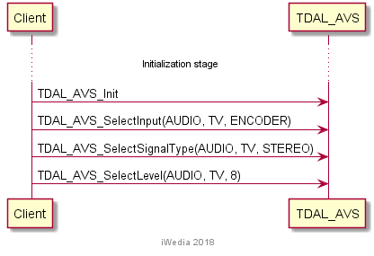

Set Video on Scart TV
The initialisation of TDAL_AVS API is made. The signal source, the signal type, the slowblanking and the fastblanking are set by the others functions.

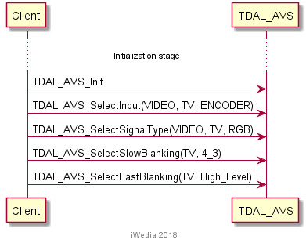

Set a loopthough (ScartTV from ScartVCR)
The initialisation of TDAL_AVS API is made. Select the input signal for the audio and video output. Activate the fast blanking from the VCR.

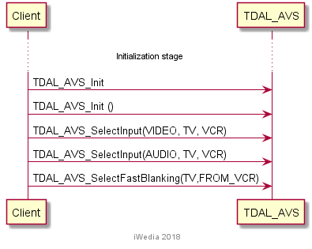

TDAL_AVS Macro/Define/Enum/Typedef/Structure Definitions

Define Definitions

kTDAL_AVS_MAX_VALUE_TV_AUDIO_LEVEL
This constant is used to define.the number of level supported by the audio. This constant is given to the application.
#define kTDAL_AVS_MAX_VALUE_TV_AUDIO_LEVEL (14)
Note:
14 is the value currently used by the application.

Enum Definitions

tTDAL_AVS_Error
An enumeration of the different possible error returned by TDAL_AVS.
typedef enum
{
eTDAL_AVS_NO_ERROR, /* No Error returned */
eTDAL_AVS_NOT_INIT, /* TDAL_AVS no initialised */
eTDAL_AVS_BAD_PARAMETER, /* Bad parameter given to the function */
eTDAL_AVS_NOT_IMPLEMENTED, /* feature not available */
eTDAL_AVS_NOT_DONE /* Low level driver returns an error */
} tTDAL_AVS_Error;

tTDAL_AVS_Object
An enumeration of the different object handled by TDAL_AVS.
typedef enum
{
eTDAL_AVS_AUDIO = 0,
eTDAL_AVS_VIDEO
}tTDAL_AVS_Object;
Audio:
This object is used to control all the audio anolog signals.
Video:
This object is used to control all the video anolog signals.

tTDAL_ AVS_OutputDevice
An enumeration of the different possible output managed by TDAL_AVS module.
typedef enum
{
eTDAL_AVS_OUT_AUX
eTDAL_AVS_OUT_VCR,
eTDAL_AVS_OUT_TV,
eTDAL_AVS_OUT_RCA,
eTDAL_AVS_OUT_SVIDEO
}tTDAL_AVS_OutputDevice;

tTDAL_ AVS_InputDevice
An enumeration of the different possible input managed by TDAL_AVS module.
typedef enum
{
eTDAL_AVS_IN_AUX
eTDAL_AVS_IN_VCR,
eTDAL_AVS_IN_TV,
eTDAL_AVS_IN_ENCODER
}tTDAL_AVS_InputDevice;

tTDAL_AVS_SignalType
An enumeration of the analog signals identifiers supported by TDAL_AVS module.
typedef enum
{
eTDAL_AVS_CVBS,
eTDAL_AVS_CHROMA,
eTDAL_AVS_RGB,
eTDAL_AVS_MONO,
eTDAL_AVS_STEREO,
eTDAL_AVS_RCA_GAIN_AS_TV, /* The RCA Volume follows the TV volume*/
eTDAL_AVS_RCA_GAIN_CONSTANT /* The RCA volume is always the same */
}tTDAL_AVS_SignalType;

tTDAL_AVS_MuteState
An enumeration of the output state supported by TDAL_AVS module.
typedef enum
{
eTDAL_AVS_MUTE_OFF = 0,
eTDAL_AVS_MUTE_ON,
}tTDAL_AVS_MuteState;

tTDAL_AVS_FastBlankingLevel
An enumeration to use the Blanking with TDAL_AVS module.
typedef enum
{
eTDAL_AVS_FB_FORCED_LOW_LEVEL,
eTDAL_AVS_FB_FORCED_HIGH_LEVEL,
eTDAL_AVS_FB_FROM_ENCODER,
eTDAL_AVS_FB_FROM_VCR
}tTDAL_AVS_FastBlankingLevel;
Low Level:
This enum means that the signal is composite with a transparent RGB.
High Level:
This enum means that the signal is RGB only.

tTDAL_AVS_SlowBlankingLevel
An enumeration to use the Slow Blanking with TDAL_AVS module.
typedef enum
{
eTDAL_AVS_SB_INPUT_MODE,
eTDAL_AVS_SB_STANDBY_MODE,
eTDAL_AVS_SB_16_9_FORMAT,
eTDAL_AVS_SB_4_3_FORMAT,
..eTDAL_AVS_SB_AS_SLB_VCR
}tTDAL_AVS_SlowBlankingLevel;
Standby Mode:
This enum means internal bypass.
Input Mode:
This enum means no signal.
16_9 and 4_3 format:
This enum means a widescreen(16/9) or a normal (4/3) signal.
SB_AS_SLB_VCR:
This enum is used to avert that the type of video present on the scart TV will be the same that on the VCR scart.

Structure Definitions

tTDAL_AVS_Level
Description:
Parameter to give the level of the audio requested by application.
Definition:
uint16_t tTDAL_AVS_Level;

TDAL_AVS API Functions

Generic Interface API

TDAL_AVS_Init(-)
Prototype:
tTDAL_AVS_Error TDAL_AVS_Init (void);
Description:
This function initialises the communication with Audio/Video Switch Chip.
Return value:
It returns eTDAL_AVS_NO_ERROR if initialization succeed or eTDAL_AVS_NOT_DONE, otherwise.
Parameters:
None.
Comments:
This function must be called before any other functions of the TDAL_AVS API.
See Also:
TDAL_AVS_Term(-).

TDAL_AVS_Term(-)
Prototype:
tTDAL_AVS_Error TDAL_AVS_Term (void);
Description:
This function terminates the TDAL_AVS module.
Return value:
It returns eTDAL_AVS_NO_ERROR if termination succeed.
It could be eTDAL_AVS_NOT_INIT_ERROR otherwise.
Parameters:
None.
Comments:
Any function of TDAL_AVS API should not be called after TDAL_AVS_Term(-) call.
See Also:
TDAL_AVS_Init(-).

TDAL_AVS_SelectInput(-)
Prototype:
tTDAL_AVS_Error TDAL_AVS_SelectInput
(
tTDAL_AVS_Object object,
tTDAL_AVS_OuputDevice outputDevice,
tTDAL_AVS_InputDevice inputDevice
) ;
Description:
This function set the way of the a signal audio or video.
Return value:
It returns eTDAL_AVS_NO_ERROR, if no error.
eTDAL_AVS_NOT_INIT, if TDAL_AVS driver has not been initialized.
eTDAL_AVS_BAD_PARAMETER, if one or several parameter(s) are not valid parameter(s)..
Parameters:
Parameter | Type | Dir | Description
object | tTDAL_AVS_Object | In | Object to modify
outputDevice | tTDAL_AVS_OuputDevice | In | Target device
inputDevice | tTDAL_AVS_InputDevice | In | Device in input
Comments:
This function can be called at any time the TDAL_AVS has been initialised with TDAL_AVS_Init(-) but not after the termination with TDAL_AVS_Term(-).
See Also:
tTDAL_AVS_Object
tTDAL_ AVS_OutputDevice
tTDAL_ AVS_InputDevice

TDAL_AVS_APIRevisionGet(-)
Prototype:
Cont char *TDAL_AVS_APIRevisionGet(void);
Description:
This function retrieves the API revision.
Return value:
A string containing the revision of the TDAL_AVS API.
Parameters:
None.
Comments:
This function can be called at any time.
See Also:

TDAL_AVS_PlatformRevisionGet(-)
Prototype:
Const char *TDAL_AVS_PlatformRevisionGet(void);
Description:
This function retrieves the platform implementation revision.
Return value:
A string containing the revision of the TDAL_AVS implementation on a platform.
Parameters:
None.
Comments:
This function can be called at any time.
See Also:

TDAL_AVS_SelectSignalType(-)
Prototype:
tTDAL_AVS_Error TDAL_AVS_SelectSignalType
(
tTDAL_AVS_Object object,
tTDAL_AVS_OuputDevice outputDevice,
tTDAL_AVS_SignalType signalType
) ;
Description:
This function set the type of the signal audio or video.
Return value:
It returns eTDAL_AVS_NO_ERROR, if no error.
eTDAL_AVS_NOT_INIT, if TDAL_AVS driver has not been initialized.
eTDAL_AVS_BAD_PARAMETER, if one or several parameter(s) are not valid parameter(s)..
Parameters:
Parameter | Type | Dir | Description
object | tTDAL_AVS_Object | In | Object to modify
outputDevice | tTDAL_AVS_OuputDevice | In | Target device
SignalType | tTDAL_AVS_SignalType | In | Signal to set
Comments:
This function can be called at any time the TDAL_AVS has been initialised with TDAL_AVS_Init(-) but not after the termination with TDAL_AVS_Term(-).
See Also:
tTDAL_AVS_Object
tTDAL_ AVS_OutputDevice
tTDAL_AVS_SignalType

TDAL_AVS_SelectLevel(-)
Prototype:
tTDAL_AVS_Error TDAL_AVS_SelectLevel
(
tTDAL_AVS_Object object,
tTDAL_AVS_OuputDevice outputDevice,
tTDAL_AVS_Level level
) ;
Description:
This function set the level of the signal audio.
Return value:
It returns eTDAL_AVS_NO_ERROR, if no error.
eTDAL_AVS_NOT_INIT, if TDAL_AVS driver has not been initialized.
eTDAL_AVS_BAD_PARAMETER, if one or several parameter(s) are not valid parameter(s)..
Parameters:
Parameter | Type | Dir | Description
object | tTDAL_AVS_Object | In | Object to modify
outputDevice | tTDAL_AVS_OuputDevice | In | Target device
level | tTDAL_AVS_Level | In | level to set
Comments:
This function can be called at any time the TDAL_AVS has been initialised with TDAL_AVS_Init(-) but not after the termination with TDAL_AVS_Term(-).
See Also:
tTDAL_AVS_Object
tTDAL_ AVS_OutputDevice
tTDAL_AVS_Level

TDAL_AVS_Mute(-)
Prototype:
tTDAL_AVS_Error TDAL_AVS_Mute
(
tTDAL_AVS_Object object,
tTDAL_AVS_OuputDevice outputDevice,
tTDAL_AVS_MuteState muteState
) ;
Description:
This function mutes or unmutes the output audio or video.
Return value:
It returns eTDAL_AVS_NO_ERROR, if no error.
eTDAL_AVS_NOT_INIT, if TDAL_AVS driver has not been initialized.
eTDAL_AVS_BAD_PARAMETER, if one or several parameter(s) are not valid parameter(s)..
Parameters:
Parameter | Type | Dir | Description
object | tTDAL_AVS_Object | In | Object to modify
outputDevice | tTDAL_AVS_OuputDevice | In | Target device
muteState | tTDAL_AVS_MuteState | In | Mute or Unmute
Comments:
This function can be called at any time the TDAL_AVS has been initialised with TDAL_AVS_Init(-) but not after the termination with TDAL_AVS_Term(-).
See Also:
tTDAL_AVS_Object
tTDAL_ AVS_OutputDevice
tTDAL_AVS_MuteState

TDAL_AVS_SelectSlowBlanking(-)
Prototype:
tTDAL_AVS_Error TDAL_AVS_SelectSlowBlanking
(
tTDAL_AVS_OuputDevice outputDevice,
tTDAL_AVS_SlowBlankingLevel SBlevel
) ;
Description:
This function set the type (slowblanking) for the signal video.
Return value:
It returns eTDAL_AVS_NO_ERROR, if no error.
eTDAL_AVS_NOT_INIT, if TDAL_AVS driver has not been initialized.
eTDAL_AVS_BAD_PARAMETER, if one or several parameter(s) are not valid parameter(s)..
Parameters:
Parameter | Type | Dir | Description
object | tTDAL_AVS_Object | In | Object to modify
outputDevice | tTDAL_AVS_OuputDevice | In | Target device
SBlevel | tTDAL_AVS_SlowBlankingLevel | In | 16_9/4_3/STBY
Comments:
This function can be called at any time the TDAL_AVS has been initialised with TDAL_AVS_Init(-) but not after the termination with TDAL_AVS_Term(-).
See Also:
tTDAL_AVS_Object
tTDAL_ AVS_OutputDevice
TDAL_AVS_SelectSlowBlanking(-)

TDAL_AVS_SelectFastBlanking(-)
Prototype:
tTDAL_AVS_Error TDAL_AVS_SelectFastBlanking
(
tTDAL_AVS_OuputDevice outputDevice,
tTDAL_AVS_FastBlankingLevel FBlevel
) ;
Description:
This function set the source of the signal and switch signal video.
Return value:
It returns eTDAL_AVS_NO_ERROR, if no error.
eTDAL_AVS_NOT_INIT, if TDAL_AVS driver has not been initialized.
eTDAL_AVS_BAD_PARAMETER, if one or several parameter(s) are not valid parameter(s)..
Parameters:
Parameter | Type | Dir | Description
object | tTDAL_AVS_Object | In | Object to modify
outputDevice | tTDAL_AVS_OuputDevice | In | Target device
FBlevel | tTDAL_AVS_FastBlankingLevel | In | RGB/Composite
Comments:
This function can be called at any time the TDAL_AVS has been initialised with TDAL_AVS_Init(-) but not after the termination with TDAL_AVS_Term(-).
See Also:
tTDAL_AVS_Object
tTDAL_ AVS_OutputDevice
tTDAL_AVS_FastBlankingLevel

TDAL_AVS_EnableAutomaticLoopthrough(-)
Prototype:
tTDAL_AVS_Error TDAL_AVS_SelectFastBlanking
(
bool enable
) ;
Description:
This function enable or disable the loopthrough.
Return value:
It returns eTDAL_AVS_NO_ERROR, if no error.
eTDAL_AVS_NOT_INIT, if TDAL_AVS driver has not been initialized.
eTDAL_AVS_BAD_PARAMETER, if one or several parameter(s) are not valid parameter(s)..
Parameters:
Parameter | Type | Dir | Description
enable | bool | In | Tru/false
Comments:
This function can be called at any time the TDAL_AVS has been initialised with TDAL_AVS_Init(-) but not after the termination with TDAL_AVS_Term(-).
See Also:

